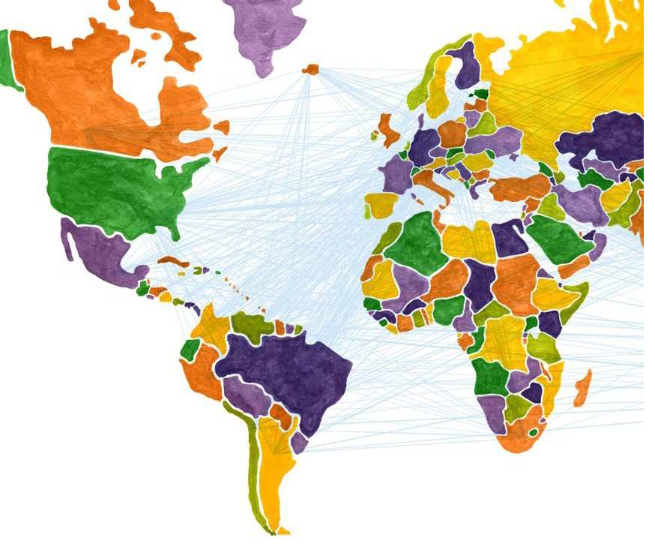
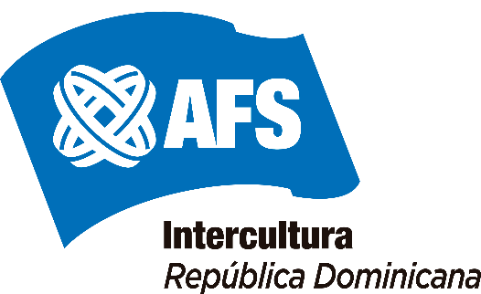

2021
Handbook
For school program students in the Dominican Republic
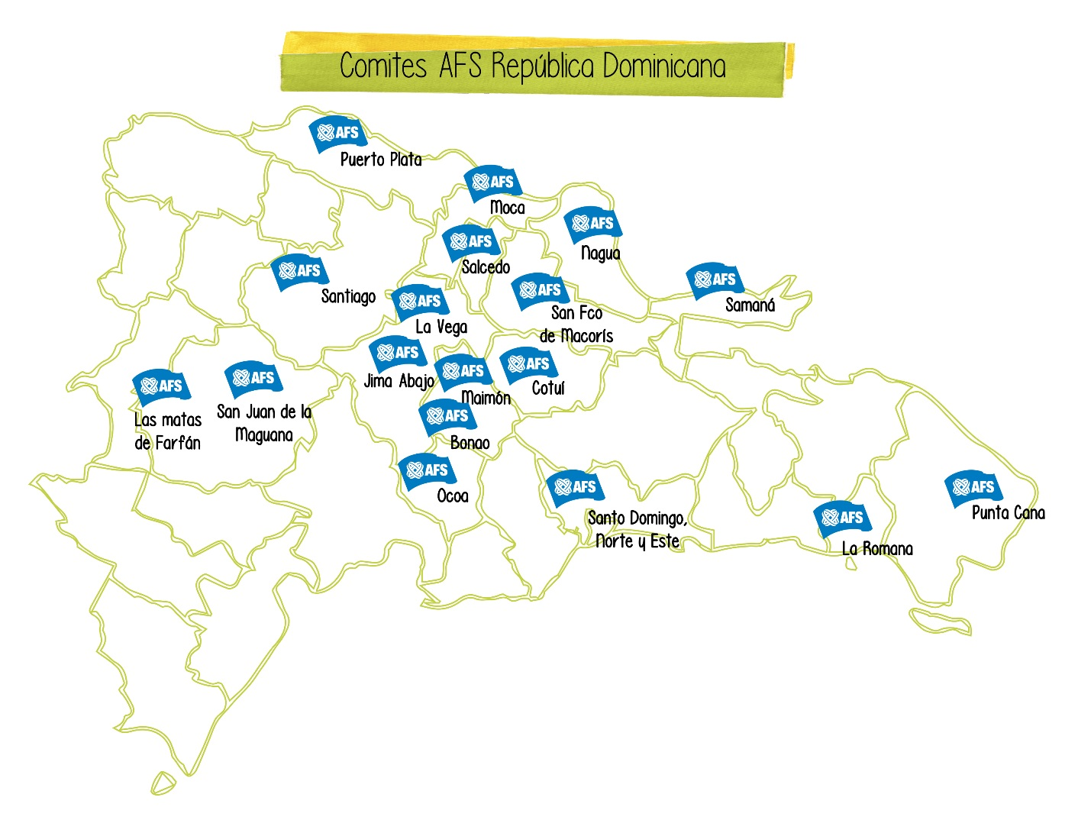

Contents

1. ¡Bienvenido!
2. The Program: “Dominican Experience”
Your Host Family
Your Host school
Host Chapter: Community Service
Communication channel

3. DOM 101:
History
Geography
Climate
Economy
Regions: cultural differences within DOM

4. DOM Culture 101:
The Dominican People
Food, Music and Language
Religion and Moral values
Traveling
Inside Home
Extra activities

5. Culture Shock detector:
Public Services
Difference in social classes
USA influence
Gender relations
Sexuality: reality or taboo
Being away from home

6. Program grounding:
AFS Rules
Medical matters & Insurance
Fees and refund policy
Safety issues: Insurance
Visa
What to bring?
Contact

- ¡Bienvenido!

We are very happy that you have decided to participate this year as an AFS student in our country. We wish to begin communications so that we can help you prepare as much as possible for your AFS experience, which we hope will be one of the best times of your life.
We urge you to start preparing for your trip right now by studying as much Spanish as you can, and by learning more about our country. We have put together this handbook that covers some of the aspects of life in The Dominican Republic to help you prepare for your stay.
Your AFS experience will be a time of personal growth; it will have its good and not so good times, and it will demand your effort and interest in adapting to very different ways of living. ACTIVE PARTICIPATION WITH YOUR HOST FAMILY IS OF GREAT IMPORTANCE, as are the other aspects of your stay, such as work and community involvement.
We would like for you to feel confident about getting in touch with us at any time during your stay. AFS Dominican Republic, the Central Office, members of the local committee and your counselors are willing and ready to help you. Whether you are in need of advice, guidance or just someone to lend a hand, you can always turn to us. Remember, you are not alone.
You are now a member of the worldwide AFS family. We welcome you into this international community and express our hopes that you have an unforgettable and memorable stay in the Dominican Republic.

¡Bienvenido!

- The program:
The Dominican experience

Your host family
Both, you and your new family, have been expecting a new experience. Your host family is willing to open up and give you the opportunity to become a new family member. This family can be very different from what you have imagined, it can be big or small, with both parents or a single one, same age siblings or none, and they are from different social classes: low, medium or high. Maybe very much like your natural family or quite the opposite. What’s truly important for a successful AFS experience is that from now on, you should be open up for the unexpected, unimagined, and prepare to accept what is new and different.
All participant s will live with host families in different cities located all over the country: countryside, on the mountains, near the beaches, in small town or in bigger cities like the capital. Family information will be given to you, prior departure from your home country.
It is very important for you to know that families here are very conservative. Parent’s decisions are respected and followed and they have the last word in discipline and other matters. Children are allowed to give their opinion, but not all parent s will accept openly to negotiate a point if they are demanded.
Families host voluntarily; they want to host you because they are willing to share what they have (even if it's little). Show t hem you are grateful, your appreciation is necessary to build a lasting bond between you and your host family, friends and the community.
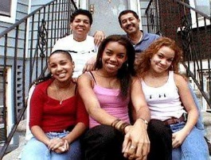
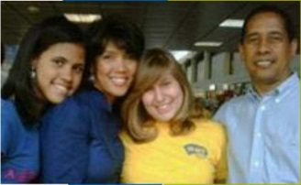
Your host school
School will be an important and integral part of your experience in the Dominican Republic and your attendance and active participation is essential.
School is in session from August to June, from 7:45 am to 4:00 pm, from Monday through Friday. You will be attending a public or private school, which might provide a scholarship to help pay for your tuition. Therefore, the school will expect you to do your best at maintaining good grades during the year. All subjects are mandatory, so requests for special subject s cannot be accommodated.
Education starts in Pre-Kindergarten up to Pre First, and afterwards schools are organized as follows: elementary school: from 1st to 6th grade. Secondary school: from 7th to 12th grade (which means that most students graduate with 18 years old). Usually, AFS students attend 10th, 11th or 12th grade, depending on the last course taken in their own country. The Board of Education is the one that decides the grade you will be going to.
The subjects established for each of the courses are the following:
2nd Year (10th Grade)
Spanish Grammar; Logic, Algebra and Geometry; English and French as a second language; Physics and Biology; Latin American History and Geography; Civics; Art; Religion; Electricity; Computer Science; Physical Education and Counselling.
3rd Year (11th Grade)
Spanish Literature; Trigonometry; English and French as a second Language; Chemistry and Biology; Dominican History and Geography; Civics; Art; Religion; Agropecuaria; Computer Science; Physical Education and Counselling.
4th Year (12th Grade)
Latin American Literature; Pre-Calculus, English and French as a second language; Physics and Chemistry; Dominican Sociology and Economics; Civics, Art; Religion; Commercial Education; Computer Science; Physical Education and Counselling.
These are the subject that generally are useful if you want to go to the University. Schools like Polytechnics may have a different offer for the students, but it depends on each school.
The extracurricular activities in school are sports, music, dance, theatre; it depends of each school. AFS encourages you to take an active part in any extracurricular activities that interest you, and in your local community. This will allow you to make the most of the opportunity to learn about different aspects of life in the Dominican Republic.
When you attend school in the Dominican Republic, don't be intimidated by your lack of language ability; just jump in and try to communicate. School will give you the opportunity to meet and interact with many Dominicans of your age group. Please, don't despair if your scholastic achievement takes a while before they pick up. Learning the language and trying to follow up with what is going on is quite a task at the beginning.
All the elementary and secondary schools in the country are regulated by the Ministry of Education (MINERD) and most of the Private ones have some kind of religious affiliation (usually catholic). To assist to school is not mandatory according to the laws, but high school degree is a must for any job application. Public Education System is being renovated and each year is more efficient now that it receives a 4% of all the money earned by the Government. At this time the State is working for the teacher’s training, new materials and facilities. There are certain regions though, where public school is the only possibility to study high school.
School Books
AFS will pay for your school books, but first you have to check with the AFS Central Office, since there are lots of books from former students that might be available at the office.
If the books you need are not available at the office, then you must buy them and send the bill together with the booklist to the AFS Central Office for reimbursement.
Notebooks, pencils and other school materials are not paid for by AFS.
VERY IMPORTANT
Dominican students are required to wear uniforms to school and each school have their different uniform. Make sure to bring US$100 to cover the cost of purchasing the uniform when you arrive. Keep in mind that wearing a uniform will greatly reduce the number of outfits you would otherwise need to bring with you. Please bring a pair of black shoes and all white tennis shoes, or both, since most of the schools will have them as part of their uniform. This will spare you some money.
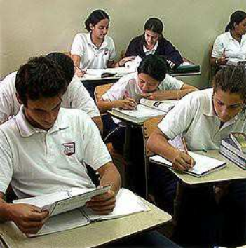

Validation System
In order to get the recognition of the school year abroad, it is clear that will be up to your natural School validation requirements, which for some may be very simple, but in the Dominican Education System, schools normally demand a formal process with the Educational Ministry, because otherwise as an Inter- institutional collaboration they won’t issue documents like school grades without following the formal process., which it is:
Before going abroad:
• Original Birth Certification (including the names of both parents)
• Original School records from 8th grade until last school year

Before starting school: These documents must be translated to Spanish by a recognized Translator from the Ministry in order to work with the proper language. This translation costs around US$120, and must be paid at the beginning of the process. This can be arranged by AFSDOM since we have the relation with this facilitator, so in case you are interested on doing this process you should do it from the beginning, otherwise we won’t be able to help you.
The result of this translation and submission of documents will be a Resolution from the Educational Ministry recognizing your school level and letting you know the subjects you must approve in order to continue your studies under the Dominican System. This might mean that subjects from previous levels that you have never taken you will need to study them and exam, like Latin American History.
After final exams, at the end of the year:
You will need to gather the following documents:
School Record, with headed paper, stamped and signed by the principal of the school and the District of Education that the School belongs to. Check that School Record has your names and surnames used at the Birth Certificate and includes the resolution number given to you in order to continue your studies in the Dominican Republic.
Birth Certification (including the names of both parents).
Resolution initially issued to you by the MINERD.
In order to legalize the Documents: Take these three documents to the Ministry of Education at the Department of Accreditation and Recognition on second floor, where they will check your documents and with their permission you’ll go to the first floor and you will proceed to legalize it.
At any time you can always ask AFSDOM for help or information.
Participants have the option of requesting simpler documentation, or specific requirements according to the natural school directly to the host school and teachers, but these are not useful for the proper process of validation.
Local Chapter
Most participants get to be hosted in the same city that the local Chapters of AFS works. These chapters are groups of volunteers that are supporting the intercultural process of adaptation of both, participants and Host families. The chapters are held by volunteers that vary in age, gender, knowledge, and experience. Not all volunteers speak English, but they are willing to search for ways to communicate with participants. This is important for you to know because they will also need your cooperation to communicate until you learn some Spanish.
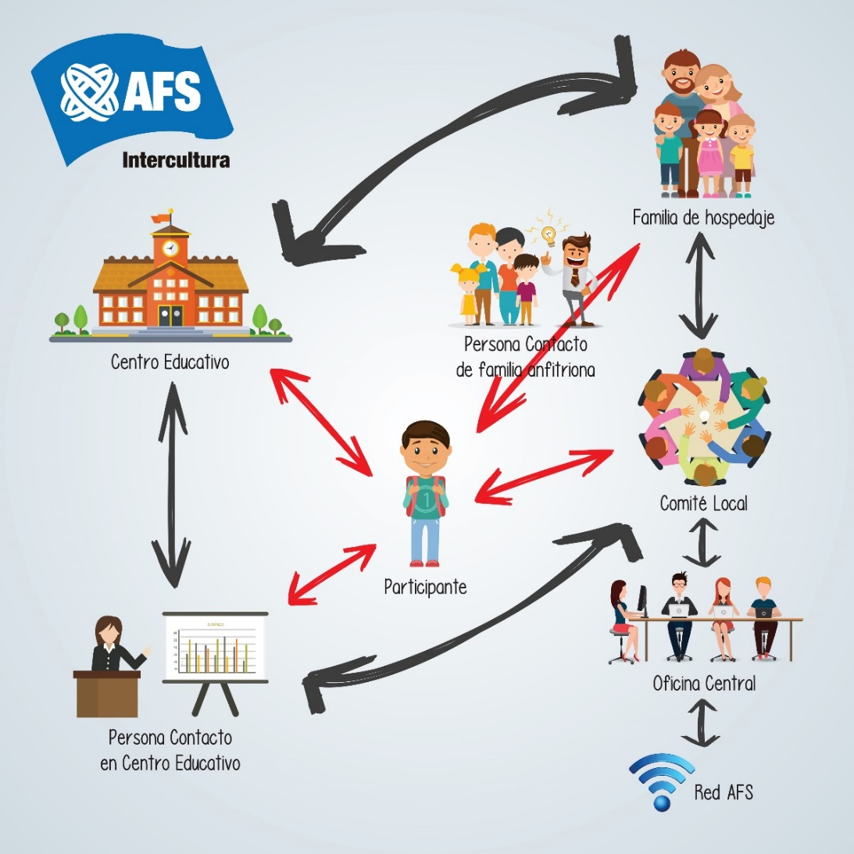
Comunication channels

- DOM
History
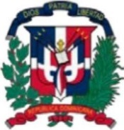
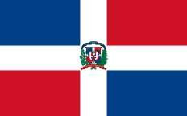

The flag The coat of arms

The Dominican Republic was discovered by Christopher Columbus on December 5, 1492. Columbus named the island La Hispaniola, and its capital city Santo Domingo was founded in 1496 when Bartholomew, brother of Columbus, was appointed governor.
After the Spaniards arrival the Taino Natives, the original inhabitants, were put into slavery and years later, they were eventually wiped out. The Island of Hispaniola remained under Spanish rule until 1697 when the all island became a French possession. Later, with the slave revolution, the western part became the Republic of Haiti, in 1804. Later the eastern side of the island returned to Spanish rule. And in 1821 the Spanish settlers in the east part of the island declared an independent state. Weeks later, Haitian forces from the west invaded the eastern portion and incorporated the total island in one republic.
For the next 22 years the entire island came under Haitian control and on February 27, 1844, the eastern side of the island declared independence and gave their land the name "Dominican Republic".
The 70 years that followed were characterized by political unrest and civil war, mainly due to fights for leadership of the government by Dominican strongmen. From 1916 until 1924 the US Army forces invaded the Dominican Republic.
In 1930 began the dictatorship of a sergeant of the Dominican Republic’s army named Rafael Leonidas Trujillo, who ruled for 31 years and was assassinated in 1961. After this Juan Bosch became the first democratically elected president in 4 decades, stayed only 7 months. In 1965 the US Government invaded the country for a second time, until 1966 when Joaquin Balaguer won in free election against Bosch who intended to be President for the second time. Balaguer remained in power until the 1978. And in 1996 for a total of 20 years as president.
The actual President is Danilo Medina.
Location and stats
AREA: 48,442 Km 2 (18,704 sq mi) CAPITAL: Santo Domingo de Guzmán
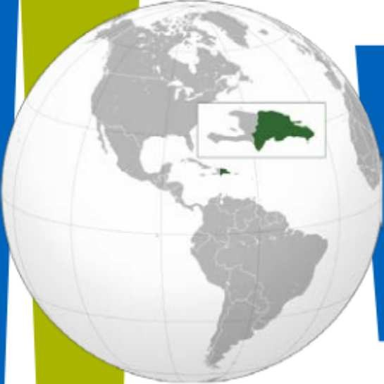
BORDERS: Atlantic Ocean (North) Caribbean Sea (South) Republic of
Haiti (W est) Canal de la Mona & Puerto Rico (East) Coastline: 1,575
Kms. POPULATION: 10,090,000. OFFICIAL LANGUAJE: Spanish
TIME ZONE: Atlantic UTC-4. CALLING CODE: 1-809, 1-829, 1-849
DRIVES: On the right. INTERNET TLD: .do
CURRENCY: Peso (DOP). GOVERMENT: Democratic

Geography
The Dominican Republic is situated on the eastern part of the second-largest island in the Greater Antilles archipelago. Dominican Republic shares the island with Haiti at roughly 2 to 1 ratio. It has an area of
48,442 square kilometers and a 1575-kilometer coastline; one third of which is covered by magnificent beaches.
The country's mainland has four important mountain ranges: The Cordillera Septentrional ("Northern Mountain Range"), which extends from the northwestern town of Monte Cristi, near the Haitian border, to the Samaná Peninsula in the east, running parallel to the Atlantic coast.
The Cordillera Central ("Central Mountain Range"). The highest of the Caribbean’s ranges. In the Cordillera Central are found the four highest peaks in the Caribbean: Pico Duarte (3,098 meters above sea level), La Pelona (3,094 meters) La Rucilla (3,049 meters) and Pico Yaque (2,760 meters).
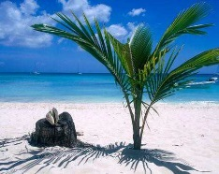
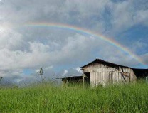
Climate
The majority of the Dominican Republic enjoys beautiful tropical weather all year round, with the average annual temperature hovering around 25°C(77°F)
There are slight variations between the summer and winter months. The winter season, runs from November to April. The humidity is relatively low during these months and it tends to cool down in the evenings much more than in the summer months. The coast al/ beach regions generally experience highs of around 28°C (83°F) during the day and lows of about 20°C (68°F) in the evening. The mountainous interior of the country is considerably cooler, and on the highest mountain peaks the thermometer can sometimes drop below freezing point.
The summer season in the Dominican Republic runs from May to October. Average daily highs for the coastal/ beach regions rise to around 31°C (87°F) during the day, dropping down to about 22°C (72°F) at night. It is the higher humidity during this period that can make it feel much hotter during this season.

Economy
The main pillars of the Dominican economy are agriculture and agro industry, mining, tourism and industrial free zones. Our main products for export are: pineapples, sugar cane, rice, tomatoes, oranges, plantains, bananas, cacao, coffee and tobacco. Infertile and shallow lands are used for livestock growing and fruits. Mining activities are concentrated mainly in The Cibao (north region), where there are great deposits of ferronickel and the continent's largest open-pit gold mine.
The most important industry in Dominican Republic is tourism, which brings high incomes and better life for their employees. In the past years, Duty Free Industries have increased in number.
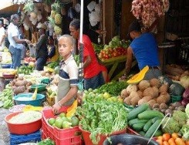
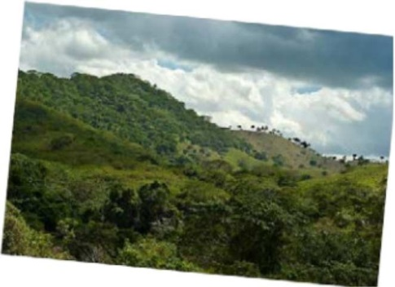

Cultural differences by region
The country is divided in three major regions: North, East, and South. The development of each region is related basically on their agricultural growth through the years, which is conditioned by each regions climate.
Up North, is the biggest region, better known by its prosperity on agriculture, and agro industry, mining, tourism and industrial free zone.
East region is geographically plainer than the others, and has recently dedicated to the development of tourism having the most beautiful beaches of the Country, in Punta Cana, Bávaro, Bayahibe, Samaná. Although, the communities that are next to these touristic attractions are developing and be organized.
The South is the less developed region and is the driest one. Its beauty, like Bahia de las Aguilas, relies on the fact that it is the less exploited area, and that communities experience a more realistic bond among its people. The south region is the nearest to Haiti, and its cultural influences give a much diverse dynamic to some of its communities.
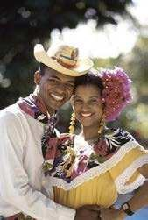
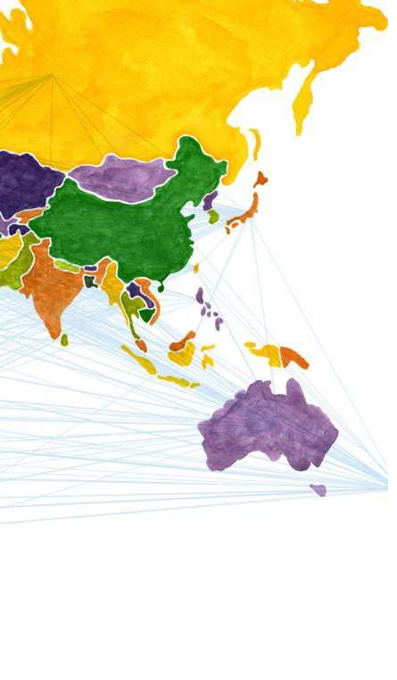
- DOM Culture
The Dominican People
Our inhabitants are a mixture of Europeans, Black Africans and Natives. The racial distribution is as follows: Mulattos (70 %), Blacks (15%), Whites (10%) and Asians (5%).
Most Dominicans share similar ways of thinking, acting and feeling and have a strong self-image, as reflected in frequent comments that something is "muy dominicano" (very Dominican). We are very nationalist and proud of our country, but not in an aggressive way. Everyone feels free to criticize as much as he wants about our institutions or government, but we don't like criticism when it comes from foreigners.
Above all, Dominicans are happy and easygoing people, always ready to have fun or to laugh at a good joke. We place great importance on friendship and loyalty towards our family and friends. People are usually willing to help others, even if this means going out of their way to do so.
Selfishness and strong individualism are badly regarded. It is common to offer to share whatever you are eating and drinking. It is considered rude if you eat something in front of others without offering.
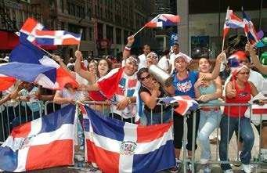
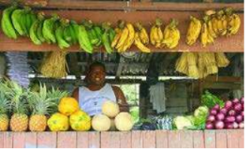
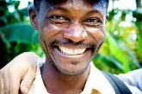
We usually take the initiative when meeting people, especially foreigners. People from other countries are always welcome, and everybody, from small children to grandparents, tries to make the visitor comfortable. Foreigners are always an attraction to our people, who are generally friendly and helpful towards them and show a lot of patience if the visitor has limitation in communicating in our language.

We are very passionate in the way we talk. In the beginning, you may think that everybody is arguing. But, don't worry. It's normal to talk like that, very loud and making gestures with our hands and face.
Conservatism and caution are deeply rooted values. Changes are accepted only little by little. This is reflected in many ways: a person could be suspicious if he/ she looks just too different; extremist political ideas are not very popular.
Of course, all things that are said in this section are only generalizations. Soon enough you will be able to make your own judgments and form your own opinion, which may be quite contrary to our own description of us.

Food, Music and Language
Food
Dominican cuisine has a lot in common with the gastronomic traditions of the neighboring islands of Cuba and Puerto Rico and will be quite different to what you are used to. Our basic meal day consists of: breakfast, lunch and diner
Breakfast: usually a traditional Dominican breakfast will include Mangú, which is a savory puree made with mashed plantains, yucca or auyama. Mangú’ is traditionally served with fried red onions, fried white cheese, eggs or salami.
Lunch: in most cases will be " la Bandera Dominicana" (the Dominican Flag) which is made up of white rice, bean stew and meat. There are many variations of this combination. The beans can be black, red or white. The rice is usually white, but Dominicans sometimes also make rice with noodles, rice with sweet corn, or rice with vegetables. Meat can be chicken, beef, pork or goat, and these are made in any number of ways: fried, stewed or roasted.
Diner: usually it consists of the same menu than breakfast or a sandwich.
Host families tend to think that if a student eats a lot she/ he will be happy. Be careful, but don't be overly concerned about food: what your family feeds you is surely clean and safe to eat, and it probably tastes very good too.
There are many food imports available, but they are very expensive and these products, may be seen as a "luxury" (cereal, imported cheese, jellies, …). Don't expect your host family to buy these things for you.
The legal drinking age is 18. Check out how your family handles this and go along with it; if they disapprove strongly of drinking alcoholic beverages, it is advisable not to insist on it; if they do not consider it a problem and if everybody drinks, accept it, even if you don't approve. The same goes for smoking. If your family strongly disapproves of you smoking in the house, smoke outside. If they smoke too much for your liking, sit by the window.
Music
There are a many different genres of Dominican music, but the two most popular are
Merengue and Bachata: Merengue is the musical genre most often associated with the Dominican Republic and has been on the Dominican musical repertoire since the mid-19th century, and in the 1930s became the dominant musical genre on the island.
The other genre that is part of the Dominican musical landscape is Bachata. Bachata was virtually unknown to Latinos outside of Dominicans but this has changed during the last decade, and Bachata is quickly overcoming the popularity of Merengue as the favorite Dominican musical genre.
Dominicans, young and adult, are very fond of dancing. Many people often go out to dance or organize parties in their homes, where the main activity will be dancing. We dance all kinds of music, but we specially enjoy meringue. Dancing is a very important part of our social life, and both, boys and girls, learn how to dance at an early age.
Language
The official language of the Dominican Republic is Spanish. Some of you have knowledge of Spanish, and some have none. Whatever is the case, it would be good if you can start taking Spanish classes right away. If you are having problems communicating in Spanish don’t worry you will find that a lot of people also speak English as a second language and this may help during the first days of your experience. The Spanish spoken on the Dominican Republic is peppered by a lot of different influences not found on other Spanish speaking countries. You will find that a lot of Taino Native words as well as African words are still used today. This coupled with the fact that Dominicans tend to use Dominican slang on most phrases, gives the Dominican way of speaking a very particular and colorful manner of expression.
Learning the Language is your first key to a successful experience, it will lead you to good relation skills at home and school, people will be interested in talking to you because of your interest on practicing, and finally it opens up opportunities to make new friends and show positive attitude to people.
Speak Spanish!!! Find a way to make yourself understood, listen closely and ask what things mean; and others will understand your effort. Keep studying and learning from books and this will help you to make a bond with classmates, make friends and be integrated on their plans as well.
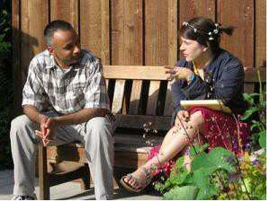
Remember: Bring a dictionary to help you at the beginning.
Religion and Moral values
Most Dominicans share similar ways of thinking, and this cultural homogeneity is shown in religion, language and values. The official religion in the Dominican Republic is Roman Catholicism. The catholic religion has a lot of importance in our society and most people practice their religion and attend church regularly. Many others go to church occasionally, or are Catholics only by name. Nowadays we are having many Christians families not catholic, and they usually are more active at Church, for example the Evangelist go to church three times a week, and the Adventist normally do not do any work from Friday at 6pm until Sunday.
Families put a lot of emphasis on religion and many private schools are religious ones. If you don’t feel comfortable to assist to the Church’s activities, speak freely with your family.
Many Dominicans believe they must be resigned to the will of God and usually add the phrase “Si Dios quiere" (God willing) to any mention of plans, even in something as simple as “See you tomorrow". There is absolute freedom of religion and different churches are found in many cities.
Values: We place great value on education, courtesy and social rituals, such as the proper ways of greeting and saying good-bye. Men shake hands, pat shoulders and often embrace; women embrace and pat shoulders, perhaps touch cheeks and kiss the air. They ask after one's health and that of the entire family. There is a specific thing to say in almost every situation: Buen día (good morning), Por favor (please) and Muchas gracias (thank you). These expressions are constantly used here.
Be aware that values are different from family to family and you should adapt accordingly to your current surrounding.
Some conducts will be acceptable in some places and won’t be so acceptable in others.
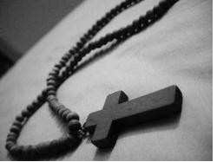
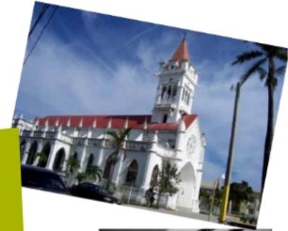
Dominican families are usually very conservative and put great emphasis on their moral appearance. They tend to care very much about how society in general perceives them and they tend to act accordingly.

Traveling
AFS is not a travel agency. The main purpose of your stay in the country is to learn our language and culture. You may be interested in traveling around alone to see more of the Dominican Republic, but this may affect the relationship with your host family and community and therefore is not allowed.
Under certain conditions you will make trips with your host family while you are on the program. The same is true if you wish to visit relatives or friends living in the Dominican Republic. In these situations, you will follow the travel procedures, as explained in the AFS rules.
Trips sponsored by your school must be approved by your host family and AFS local volunteer contact. AFS won't pay any school trip, so this is the entirely responsibility of the student.
Inside your home
Once inside the Dominican home you may find that things are done in a different way than what you are used to. But don’t worry; we have organized a simple list of things that you should know about. Simply ask your host parents or host brother/ sister any of these questions whenever you have any doubts or when the necessity arrives.
• How should I call you: mom, dad or by your first name?
• What else am I expected to do daily other than making my bed, keeping my room tidy, cleaning the bathroom every time I use it...?
• Where should I keep my dirty clothes until wash day?
• Should I wash I keep my dirty clothes until wash day?
• Should I wash my own underclothes?
• May I use the washing machine, and or iron at any time? If yes how do they work?
• Where can I keep my bathroom accessories and what’s the procedure for using the bathroom?
• What time do you usually have meals? Do I have permanent shores at meal time? May I help myself to food and drinks between meals or must I ask first?
• Are there strictly private areas at home?
• Where can I put my clothes?
• May I use: the computer, piano, sewing machine…?
• Where should I store mi suitcase?
• What time must I get up on weekdays and what time on Sundays?
• What time do you usually go to bed on week days?
• What are your rules about going out at night?
• Do you expect me to phone if I’m going to be late or miss the bus?
• May I invite mi friends to the house to eat or sleep?
• May I personalize my room?
• What are the rules about using the phone and making local and long distance phone calls?
• Where and when can I go to church/ mosque/ synagogue?
• May I watch TV or listen to the radio if I want to?

Extracurricular Activities
In our country there are limited social or extracurricular activities at school or at church, so finding these types of activities will be at the discretion and responsibility of the student himself. These activities are usually done during weekends and in the afternoon. Dominican families are very protective of their children, no matter how old they are. Your social life will be centered on family life or a small group of your brother's and sister's friends. Don't expect to be going out all the time and be prepared to inform and ask for permission to go out, even though you might be old enough or living alone in your home country.
Among the most popular extracurricular activities that you can find are: Sports (mainly baseball and basketball), Gym, taking learning classes (Guitar, dancing, painting, etc.), going to movies, etc. You will find a large array of activities or not so many depending on the city of placement.

- Culture shock detector
Public Services
Hospitals and Clinics: In the Dominican Republic Clinics are privately run and operated, this means that they are costlier but will offer better services and installations. On the other hand, there are local public hospitals that are run by the government. These are free or their services cost very little but probably won’t have all the equipment or services necessary in case of an emergency.
Electricity: In most parts of the Dominican Republic there are power outages every day. Usually these only last a few minutes or hours. Most homes and businesses have back up power in the form of a generator or batteries that charge while there is power. Most are accustomed to these power outages and have accepted these temporary blackouts as part of everyday life.
When the power does go out and there is no back up power just go with the flow. You will hear "se fue la Luz! " "There goes the lights!" and in most parts of the country the people will go out to the street to visit their neighbors or do an activity until the power is restored.
Knowing this electricity issues, please help your family turning off all the electric devices when you’re not using it, for example turn on the fans and air conditioning only if you are in the room.
Water: For the most part the potable water (drinking water) needs to be purchased in bottles, as the water supply is not suitable for drinking. You can purchase small bottles or by the gallon. Most homes have a steady water supply but in some cases water pressure will depend on electric energy; this means that if the power is out probably water too, but in these cases people t end to collect water in big containers so that when the electricity fails they still have water for everyday needs, except drinking.
Remember, when you go to the bathroom, to flush and keep it clean, as the Tropical Weather can increase the bacterial development
Public Transport at ion: Dominican public transportation may seem complex at first but once you understand the basics you will realize that the public transportation system in the Dominican Republic it’s not that complicated and it is very affordable. With the many forms of public transport including taxis, busses, motorcycles (motoconchos), public cars (publicos), small buses (guaguas), the new subway named Metro, and of course your feet, there is always a way to get to where you want to go.

Difference in Social Classes
The AFSer coming to Dominican Republic should be prepared to live under different conditions; sometimes the host family will not have the modern facilities and comfort and the latest gadgets to which you might be expecting. There is no air conditioning in most houses; very few homes have washing machines, electric dishwashers, microwave, etc. The placements we make are based on the assumption that you want and have chosen the AFS experience because it will give you a different perspective from your country.
There are sharp differences between the rich and the poor, and poverty can be seen anywhere. Rich houses are found near slums. There is no significant discrimination because of social or economic status. You will likely find that people of middle class shaking public spaces with lower class.
In recent years, the economic situation has turned very difficult for many families in general, especially those ones belonging to the middle class. So, don't think it’s weird if the family owns a big house, a luxury car and is high cultured but have some economic problems.
USA Influence
There is an evident influence of the United States in our society, especially among young people. The US influence is particularly evident in the metropolitan areas of Santo Domingo, Santiago, and the most tourist areas like Puerto Plata and Punta Cana through restaurants and stores, music, and in the people's way of dressing, in TV programs and movies. Dominicans are very fond of foreign goods and many love the idea of going abroad to shop for clothes, electrical appliances, etc.

Gender Relations
Masculine and feminine roles are clearly defined in the society and family cultures, which includes Machismo (the idea that men are superior over women). The father is usually the head of the family. His authority is respected and his words are final, even if what he says only confirms what the mother or somebody else has already decided.
This machismo has been decreasing lately, when more women have integrated to the economic and political life of the country. Still, in practice, the men of the family are granted certain privileges that women do not fully enjoy, such as minor participation in the household chores and fewer restrictions regarding social life, going out, permissions, etc.
Sexuality: Reality or Taboo
Conservative thinking and religious ground inside family education builds a huge distance from more open cultures when dealing with Sexual discussions. Topics like Sexuality, sexual activity legal age, and homosexuality, nowadays are still taboo for most families, and new generations are growing within this context, facing the question: Is sexuality reality or should it remain taboo? The answer will not come from acting differently from family’s values. This is a society in evolution, struggling for trying to keep up values and dealing with the reality that new generations are changing with time.
With this we mean that your sexual life will not be AFS's main concern (culturally), but it will be your Host family’s if it becomes noticeable for them. It is for safety reasons like health, pregnancy, violence, any type of potential rape, that we all share concerns when dealing with teenagers. So it is important that you become aware of your family's values and find ways to accept them and deal with it as part of your Intercultural Experience.
During your experience, your ability to manage your personal relations correctly from in the eyes a Dominican will depend on you being respectful, formal, and stable with your relations, demonstrating openness to Dominican values and accepting them and also caring about your family's advice. One of them should be the kind of clothes that you should wear when you go out and, maybe, also in the house.
The religious context takes a huge part of the moral values, so common practices known in your country like boyfriend/ girlfriend sleeping over in your house, being alone with him/ her in any room of the house, women being as open as man having more than one Friend (nonattached relationship), are not well seen and can make your experience very difficult when your reputation gets implicated. Dominicans tend to be very strict regarding their self-image and reputation, so when it is affected it is very hard to change or get it back. This also affects the image of Foreigners, your Country, AFS participants and more directly to your Host family, who have opened the intimacy of their home to make some space for you in there. For them, you are set to become another member of the family, so you should follow the family image. Often the behavior of other AFS generations may affect the first impression your classmates or people in your town have of you. It is up to you to show you are different and let them know you.
Being abroad, different, new and from another country, may put you in an attractive position, but always remember that this is also a threat, legal age is taken very seriously, especially for girls. Once it becomes public that a person (legal age) has had intimate relations with a minor, the law can be applied no matter age or nationality and can be claimed by ANYONE.
This and more important topic and tips will be discussed at the Arrival Orientation.
Being Away From Home
It is very likely that you will get bored every now and then, even if you should be the kind of person who never gets bored, but rather finds it difficult to find the time to do all the things you want to. Just remember that over here you don't know any people to do things with, that many of the activities you are used to do at home may not be available here, that the easiest pastimes - reading or watching TV - may be very difficult for you here because of the language problem, but it’s just in the beginning. You should know that any hobby of yours that you can bring with you (musical instruments, small sport equipment, board games, painting kits, etc.) will definitely help you spend your time usefully and to make friends and meet people. It is also always very much appreciated if you bring recipes or even special foods from your country or the area you come from and maybe cook for your family or friends sometime. What really makes all the difference is: Getting involved! Of course, there will be times when you will feel homesick- for your friends at home, for foods that you miss, for the weather at home, for a tight hug from your best friend. Unfortunately, there is no patent cure against homesickness. You have to stick it out.
If there is something very important or pressing in your mind TALK ABOUT IT!!!
If you have a problem that you can't solve on your own or if you are unhappy about something. TALK ABOUT IT!!! The first people you should always turn to are your host parents and brothers and sisters. Your host family wants you to be happy and they want to help you feel happy. Feel free to talk to them about how you feel. The only mistake you can make is not saying what goes on in your mind, really!!!
If you have the feeling that your host family cannot help you with a specific problem, there is an AFS contact just for you in your area who is willing to listen to you, and interested in how you are. Last, but no least, there is the AFS Office in Santo Domingo, where there are people who care and can help.
- Program grounding
AFS Rules:

AFS INTERNATIONAL RULES:
In the development of the AFS experience, the student is under a system of rules designed with two purposes: Student control and safety.
These rules are inviolable and the failure to comply with any one of them results in the student's immediate return to their country of origin.
INTERNATIONAL RULES:
• Do not hitchhike.
• Do not use drugs or be involved in any way with them.
• Do not drive any motor vehicle (including jet-skis).
AFS RULES OF DOMINICAN REPUBLIC:
A) Alcohol
The participant who abuses alcoholic beverages of any kind, will be returned to his native country.
B) School Accountability
• AFS students must start and complete the school year according to our academic system and the rules of the educational establishment where they study. The student should follow the guidelines regarding the school uniform, punctuality, hygiene and other characteristics specified by the school.
• All students must attend school full time. The only excuse for not attending classes is the participant's illness.
• AFS students may not leave the school before the end of school year.
• The AFS student must participate in all examinations,
• Bad behavior / bad grades in school are continuing reasons for student’s return to home country
C) Travel and visits
Each year, foreign students wishing to take advantage of their stay in the country to learn more about the different regions and landscapes of our land, however, this is not the primary reason for the exchange and, therefore, there are regulations which govern in these cases. Earnestly ask host families to ensure us the fulfillment of these rules, which seek to protect the student who may be in potential dangers, and seek to fully integrate the host school and community, basic goals of our program.

• Students can travel with the host family during weekends and holidays.
• The school's official trips are allowed. You need the permission of the host family. AFS does not reimburse the costs of these trips.
• To grant a travel permit, you need the authorization of the host family and the office of AFS and in all cases that are to Beaches, places that are not directly involved with AFS or the family or outside the country hosting: THE NATURAL FAMILYS PERMITION IS REQUIRED.
We do not give permits for independent travel (traveling alone) before the Midstay Orientation on February.
• For trips to Pico Duarte, rafting, scuba diving and other risky activity requires a written permission from the student’s natural parents.
• Permits must be requested seven {7} days in advance in order to be processed using the form for this purpose.
• AFS reserves the right to deny permits. The same is requested in the National Accommodation Coordinator.
• The days of leave for travel shall not exceed 15 days, and NEVER miss school.
• These permits include travel to other communities to visit other exchange students.
• AFS disapproves of visits from friends, family or natural parents of the student during the experience, considering the source of imbalances in the process of adaptation of the participant. If you insist on the need for such visits, they may not be until the end of the experiment (late June) and be reported one month in advance at least. AFS reserves the right to authorize or not these visits.
• Failure on abiding by any one of these rules will result in the creation of a Behavior Agreement.
• The repetition of this conduct after signing the Behavior Agreement can trigger a student's early return.
• AFS Dominican Republic has the ability to authorize or reject any travel permit.
• Students will provide AFS with an address and phone number where you can be reached during trips.
Medical Matters & Insurance
AFS International provides health insurance for all students that cover 100%. AFS does not pay expenses ophthalmologist, dentist, check-ups or any preexisting condition.
AFS students should be brought to the family doctor or physician of confidence of the host family. Be sure to keep all receipts for consultations, prescriptions and receipts for medications so that we can refund the money in full. All you have to do is send the receipts to the Central Office with a brief explanation of the treatment.
In the event of an emergency, we suggest going to your preferred local clinic or for specialized treatments go to Corazones Unidos Clinic in the Fantino Falco St. in Ensanche Naco, Santo Domingo, 809-567-4421. The expenditure in this clinic is usually reported directly to the National Bureau of AFS.
AFS shall not reimburse any incomplete medical records, so you must check thoroughly before sending the bills.
Fees and Refund Policy
Taking into account the new provisions of the Internal Revenue Department, which is mandatory for reimbursement, participants submit invoices Tax Receipt Number or valid invoice for tax credits. For this reason, everyone should know and remember our number of RNC- National Register of Contributor: 401-50232-1
1. It is necessary to check with the Central Office the list of school books. If you do not have a copy in the office, then the students or families can purchase books and will be refunded.
BOOKS NOT refunded VERIFIED THAT HAVE NOT BEEN PREVIOUSLY IN THE OFFICE. To obtain reimbursement shall deposit the list of books and invoices.
2. Books Paid for by AFS must be returned in top shape, no scratches or detached pages. If returned in poor condition, they will be charged to students.
3. Students are responsible for payment of telephone bills. We encourage host families to charge calls on students to do, even if they seem insignificant or only allow calls with a calling card if it is inside or outside. AFS is not responsible for the payment of telephone bills of the participants.
4. Students who see the need to use public transport for school should immediately notify the Office to take into account the monthly payments, using the form for this purpose. Otherwise WE DO NOT PAY RETROACTIVELY.

5. for reimbursement of medical bills from the physician need sealed, and prescription drug purchase invoice, with the above specifications. If the documentation is not complete, it will not be received at the Central Office.
6. We only pay medical bills and books within 30 days after they are bought.
8. The school uniform and materials are paid for by the student.
Visa
In order to stay here for the year program, you need a student visa. The procedure varies, so we encourage you to check with the Dominican Consulate nearer to your home in order to start the procedure.
In some cases, you'll obtain the visa once in our country. The Dominican office will be in charge of this, you just need to give the documentation and the money at the arrival camp (Maximum of US$100 for issuing the visa). Students arriving without visa we’ll need to buy a tourist card, which costs US$20 and is valid for 90 days. Before your departure there will be a US$20 Exit Tax in order to leave the country.
What to Bring
Due to the Dominican Republic's warm, tropical climate, Lightweight material clothes, t -shirts and jeans and are the standard - certainly for during the day. Light pants and jackets are recommended for the evenings, or if you'll be visiting the mountains, especially in the winter months where the temperatures can cool down at night. Higher end, restaurants and bars, may have a dress code with more specific requirements. If you are spending time in a larger city, it is recommended to have a nice set of clothing for going out in the evening. A light rain jacket (and/ or umbrella) is useful to have in the event of rain showers. If you plan to participate in sporting or adventure activities, a pair of runners/ sneakers will definitely be useful to have.
The following items are 'recommended' to bring from home. In the event you forget certain items, most Dominican Republic supermarkets and stores will probably sell most of what you might need, but items may be priced higher than if they were purchased in your home country.
Clothing
Bathing/ swim suit(s) Shorts
Tank tops & T-shirts
Long pants (for cooler weather and/ or protection from mosquitoes) Light jacket, sweater or sweatshirt (for cooler weather)
Light rain jacket and/ or umbrella
Comfortable & breathable shoes for walking around
Dress shoes for evenings out
Runners/ trainers for sports activities
Toiletries
* * Soap, shampoo & conditioner
* * Toothpaste & toothbrush
* * Waterproof sunscreen/ sun block with a high sun protection factor (SPF)
* * Any prescription medicines you may need
* * Mosquito/ bug repellant
* * Nail clippers/ nail file
* * Comb/ brush
* * Extra contact lenses & lens solution (if applicable)
Other
Pack a carry-on bag with your necessary items in case your luggage is delayed or lost
Money/ Traveler's Checks - please see our Money section for more information on this
110 Volts to 220 Volts adaptor (The Dominican Republic has a 110 Volts / 60 Hertz system. Visitors from Europe who need to use their electronic equipment such as a battery charger should bring their voltage adaptor Spanish-English (or your language) dictionary
* * for those who want to participate in the traditional Duarte’s Peak trip it would be good if you could bring a pair of hiking boots and camping equipment.
Every item mentioned above could be obtained in the Dominican Republic but, some are harder to acquire than others.

- Useful facts and realities
It is important to create awareness of the conditions of some placements in R.D., understanding that our main objective is to create diversity of placements and thus bring an authentic cultural experience. These notes will be good to help out on preparation of students during camps and for you as well when describing the expectations of our program.
• Participants must be aware that they are coming to a third world country and what this means in terms of structure development of the country.
• The student’s placement can vary from an urban city to a small countryside town.
• Dominican families vary as much as the placements; there are wealthy families with all modern facilities available, but also families with economic difficulties and families in between. Students can be placed in all of these families approved by AFS.
• Students should not be expecting modern facilities from their host family, such as hot showers, air conditioning or computers at home. Instead families have their solution to these limitations.
• The same hobbies/ activities practiced in home country might be difficult to find in DR, sometimes even impossible.
• Evening/ Weekend activities such as going to movies, bowling or eating out in restaurants or fast food places might not be possible in small towns/ rural areas.
• Taking public transportation could be the only option of going to school, visit friends etc.
• The beach might not be close to student’s host placement since student placements can be situated inland. In this case, going/ traveling to the beach is only accepted together with the host family.
• Students are only accepted to travel with their own host family members before February.
• Dominican cuisine does not vary that much and basically consists of rice and some sort of meat every day. Not necessarily many snacks are consumed during the day in a host family.
• Educational level at local schools might not be that high as in student’s home country and classmates might be younger as the student himself.
• In many cases students are expected to do different household chores such as setting the table, washing his/ her own laundry and helping around the house
• Dominicans in general are very religious people. It is common for Dominicans to wish God’s blessings when going out, greeting people or even when entering a car etc. People are used to visit and say praying & religious wishes also when someone e.g. family member is sick or facing difficulties in life.
• Independence is captured only when student can manage Spanish and is capable of surviving with it.
• Students should not expect host family to change their everyday life routines or habits for the student during the hosting period.
• Dominicans are used to work long days and maybe even study at the same time. Therefore, host family members might arrive home late in the evening.
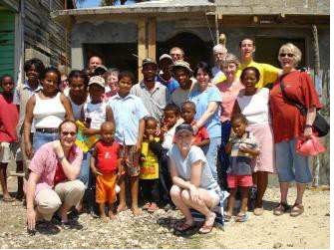
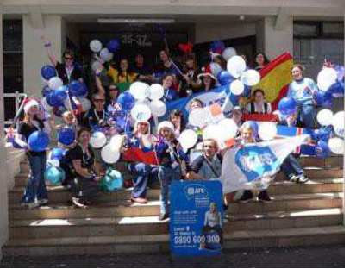
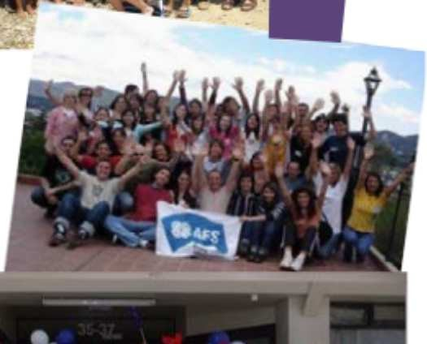
• Students should be prepared to stay home alone sometimes or only with host sisters and/ or host brothers.

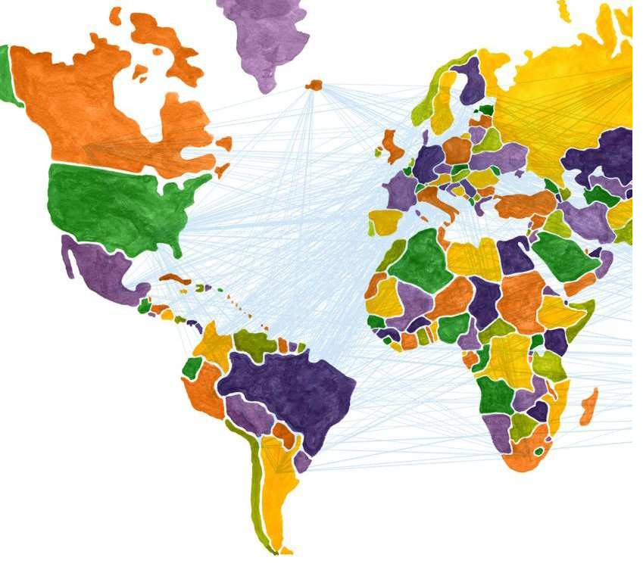
- Contact info
AFS Dominican Republic
National Office in Santo Domingo

Address: Juan Isidro Ortega St. #17, Los Prados, Santo Domingo.
Telephone: 809-338-8383
Fax: 809-621-8519
Email: info-dominicanrepublic@afs.org
Web: www.afs.do
Work Hours: 8:30am a 5:30pm from Monday to Friday
In case of emergency: 1+ 809-519-0513

