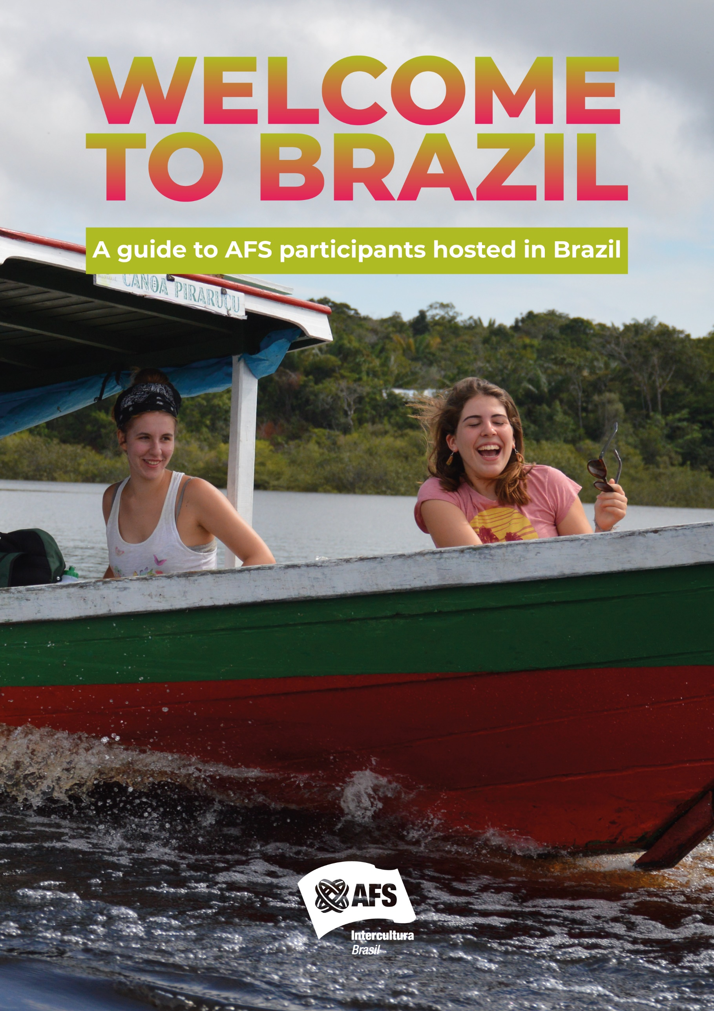

DEAR AFSer,

Welcome to AFS Intercultura Brasil!
This guide is as a resource for you to prepare to your AFS experience in Brazil and also to consult during your exchange experience! We recommend that you print it or save it in a special folder on your computer/tablet or on your mobile. There is a lot of important information here that you might need to consult during your stay.
This guide is designed to give you a brief introduction to the Brazilian culture and to provide you with basic information about AFS experience in Brazil this includes rules and information about health and safety. You will receive additional local information from your local chapter and during your arrival orientations. We will also keep in touch with you from the National Office (Secretaria Executiva) by e-mail every other month.
We hope this handbook will assist you with helpful information for you to make the best of your intercultural experience in Brazil!

Abraços,

Secretaria Executiva
AFS Intercultura Brasil

TABLE OF CONTENTS

DEAR AFSer, 2
TABLE OF CONTENTS 3
ABOUT AFS INTERCULTURA BRASIL 4
SUPPORT STRUCTURE 4
ORIENTATION PROGRAM 5
BEFORE YOUR DEPART 6
LEARNING THE LANGUAGE: ON-LINE PORTUGUESE LESSONS! 6
YELLOW FEVER VACCINE 6
MONEY 6
YOUR AFS EXPERIENCE IN BRAZIL 7
THE ARRIVAL 7
APPLYING FOR YOUR BRAZILIAN ID CARD 7
SCHOOL 8
SCHOOL TEXT BOOKS 8
SCHOOL UNIFORM 8
3 REASONS FOR YOU TO TAKE SCHOOL SERIOUSLY 8
AFS RULES 9
NO HITCHHIKING 9
NO DRIVING 9
NO INVOLVEMENT WITH ILLEGAL DRUGS 9
PROGRAM RELEASE 9
TRAVEL RULES 9
GENERAL TRAVEL RULES 10
IMPORTANT 10
OPTIONAL TRIPS 11
Observations 11
MEDICAL CARE 11
USEFUL FACTS ABOUT BRAZIL 12
SAFETY TIPS 16
CONCLUSION 19
EMERGENCIES 19

ABOUT AFS INTERCULTURA BRASIL

AFS lntercultura Brasil has a body of around 900 hundred volunteers. There are also volunteers from a variety of ages and different levels of experience. After all, AFS started its activities in Brazil on 1956.
AFS lntercultura Brasil volunteer structure is split into 10 Regions and more than 90 local chapters. lt might occur that the chapter structure differs a lot if compared to the one you are used in your home country, therefore, DO NOT expect to have the same activities. On the other hand, the volunteers will be happy to have you participate as much as you can. Feel free to offer your help and ideas.
You will have an AFS contact person at the local chapter (usually called counselor or liaison, in Portuguese "conselheiro"): someone who will be there to share the joys of your stay and help you understand the cultural differences you will face, at school, in the family and in the hosting community
There is also a LCP (local chapter president) you can refer to as well. The regional structure is filled with 2 Regional Directors for each region and a Regional Counselor in charge of specific counseling situations.
Our National Office (Secretaria Executiva - SE) is also part of your experience and is available to support you. Reach us on office hours, Mondays to Fridays, from 9:00 to 17:00. When contacting the office you should ask for the Support Area: the Support Consultants or the Coordinator will be happy to assist you!

SUPPORT STRUCTURE
AFS volunteers throughout Brazil make the exchange program possible for you. These volunteers provide a variety of important services, including orientation, guidance, counseling and support for students and host families. At the Arrival Orientation you should receive the name and phone number of the volunteers assigned to provide you with support throughout the year (conselheiro). Remember that whenever you have a problem you should go first to your HOST FAMILY and your LOCAL CONTACT PERSON, this way the problem is more quickly resolved because it follow the AFS support communication flow. If you contact your natural family first, the problem will become more complicated because more people will have to pass the word along before it can be dealt locally.
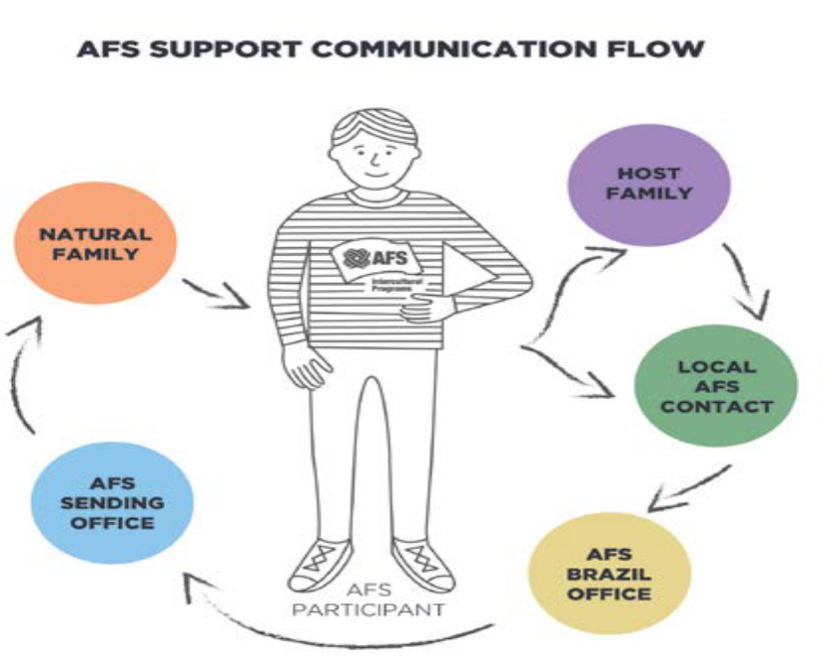

ORIENTATION PROGRAM
Adjustment and difficulties are a normal and important part of the intercultural exchange experience. AFS Orientations are scheduled at critical times of the year taking into consideration the adjustment cycle most of exchange participants go through. The AFS orientation cycle provides participants and host families with a framework for structured support and practical information. AFS orientations are often scheduled to support students during potentially difficult phases of the experiences.
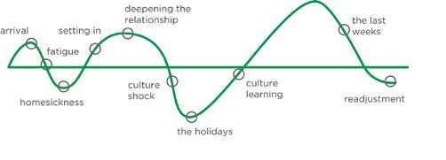
AFS has long understood that our program participants have different learning needs at different stages in their experience and AFS’ Orientations are organized to provide support to participants and host families at those times of peak difficulty. For each AFS participant, part of the orientation program is provided by the sending Partner (Pre-Departure Orientation and Reentry Orientation) and the other part by the hosting Partner (Arrival Orientation, Post-Arrival Orientation and Pre-Return Orientation).
During the first two weeks at the hosting community, local volunteers will offer an Arrival Orientation. Its objective is to outline various important elements of your stay and give you hints on adaptation into your host community and make you more familiar with it, besides reviewing needed information.
Approximately 8 to 10 weeks after your arrival you will participate in a regional, weekend long Post-Arrival Orientation where you will have the chance to exchange your views and learn more about cultural differences as well as develop a deeper understanding of the Brazilian culture.
Then, 6 to 8 weeks before you leave, you will participate in a regional, weekend long Pre-Return Orientation focusing on the last moments of your stay among us and you expectations towards returning home.
The purpose of our Orientation Program is to minimize the effects of culture shock and to support your intercultural learning experience. Your attendance is therefore mandatory!

BEFORE YOUR DEPART

LEARNING THE LANGUAGE: ON-LINE PORTUGUESE LESSONS!
AFS provides on line Portuguese lessons to participants hosted in Brazil. On 2016 we started a new methodology prepared specifically for AFS Brasil, based on communicative approach where students are able to learn basic conversation and dialogues. By taking the course you will learn basic language skills to help on initial communication with your host family and friends. Do it and have fun!
Do your best to study and practice as much as you can. Remember: the more you know at the beginning of the program, the more you get out of it!
Portuguese is a fascinating and musical language as you will soon find out! It may sound difficult in the beginning, but it will come to you little by little. Your host family is being instructed to help you whenever needed. Brazilians use a lot of body language along with the verbal message, besides it is very common to use eye contact and touching each other in the arms and shoulders while talking.

YELLOW FEVER VACCINE
For foreigners who are coming from certain countries, an International Certificate of Vaccination against yellow fever is required*. Some of those countries are: Angola, Bolivia, Central African Republic, Colombia, Congo, Ecuador, French Guiana, Panama, Peru, Rwanda, Tanzania, Togo, Trinidad and Tobago and Venezuela. However, AFS Brazil recommends that all participants coming to Brazil get a yellow fever immunization prior to arrival. During your program, you might want to take part of some trips organized by a partner travel agency, some of which require that you take at least a dose of the vaccine. Please consult with your physician, Health Department or the vaccination center in your country in order to be informed how to proceed. The immunization is effective 10 days after the shot and you will get an International Certificate of Vaccination valid for 10 years.
*Brazilian FDA Regulation RE nº 1492, issued May 28th, 2007.

MONEY
Since you will not be receiving any allowance from AFS, nor from your host family, we suggest that you bring around US$1,500 to face your own personal expenses such as postage, paper, birthday presents, movie tickets, etc. for your stay. This amount does not include the extra costs of optional trips that you might be interested in taking part during your stay (detailed information in Optional trips section). Similarly, your family may buy soap, shampoo, etc. for you but if they don´t, do it yourself graciously. Once you are here, we strongly suggest that you keep your money separate from the host families so as to avoid possible misunderstandings. If your natural family plans to send you money during your stay, the best way to do it is through a “bank draft”. Whatever currency is sent to you, it will only be available in the national currency, at the official rate.
Bringing a credit card with you is also a valid option to withdraw money from ATMs (or money machines). However, this kind of service is generally more easily accessed in big and medium size cities.

YOUR AFS EXPERIENCE IN BRAZIL

THE ARRIVAL
AFS staff and volunteers will be at the international airport to welcome you and forward you to your host community either by bus or plane, depending on the distance. The participants hosted up to 4-6 hours from the arrival gate might be met by their host family at the airport upon arrival. AFS volunteers and probably your host family as well will be waiting for you at the bus station/airport in your host community to welcome you, if this is the case.

APPLYING FOR YOUR BRAZILIAN ID CARD
Participants must register with the Federal Police within 90 days, counting from the day you arrive in Brazil. Please make sure you have approximately US$150 in the local currency (Reais) to cover the expenses related to the issuance of the ID card, such as: fees, photos (you’ll need 3), photocopies and phone calls when necessary, besides the transportation to the nearest Federal Police Station as there might not be one at your host community.
Brazilian immigration authorities can be very bureaucratic when dealing with your papers so, make sure you have the Visa Request Form (Pedido de Visto) filled with yours and your parent’s names properly spelled, exactly as it’s shown in your passport. It’s quite handy to have a copy of your Birth Certificate apostilled for school purpose as well. Your family and/or AFS volunteers will help you to obtain your ID card, but remember, it is your responsibility to provide the necessary documents and any fees for delay will be YOUR own responsibility.

You will need the following documents:
• 3 photos 3x4
• Visa Request Form
• Appointment in the Federal Police of your constituency
• Passport and copies of all pages
• Around US$150 in the local currency (Brazilian Reais)
• Federal Polices Forms (www.dpf.gov.br), fill in the forms and pay a fee at the bank. Code 140120 (204,77 BRL) and code 140082 (168,13 BRL).
• Brazilian Customs Form
• Apostilled birth certificate (This document will be required by the Federal Police when participant’s name in the visa application form does not match with the name in the passport).

SCHOOL
AFS places great importance on active school participation. It should be the focal point of your year and you are expected to attend school daily and complete the assigned coursework. Here is some general information about school in Brazil.
Brazil has only one educational system, divided into 3 parts:
Elementary Education: 9 years;
Middle Education: 3 years;
Higher Education: University.
The school year goes from February/March to December, with 2 to 3 weeks winter vacation in July. Most students attend school from Monday to Friday. Exceptions are made for those who are on the 3rd. year or during exam period. Students attend school either in the morning or in the afternoon.
There are few or no social clubs or events in Brazilian schools. Many schools do not even have school sports teams. This means that you will have to find your afternoon/morning activities depending upon which period you will attend classes outside school or organize them yourself. Maybe you can include a musical instrument or sports equipment when planning what to bring.
The Brazilian academic system is organized in a way that you will have the same classmates through the whole school year and the same schedule as well, which cannot be chosen and usually includes the following subjects: Portuguese, Brazilian Literature,
Mathematics, Geography, History, Chemistry, Physics, Biology, one foreign language (English or Spanish) and Physical Education. Very few schools will offer Arts, Photography, Computer Science, etc. Do not get upset if your school achievement takes a while before it picks up. Learning the language and trying to follow what is going on is quite a task for the start. Nobody expects you to do brilliantly on tests or exams when you are still learning the language. You will be appreciated by your teacher and classmates, though, if you try to understand and show that you are interested.

SCHOOL TEXT BOOKS
AFS will provide you with the BOOKS that you will need at school. Those books belong to AFS, but if you wish to bring them back home with you, then you have to pay for them. As for general school supplies (notebooks, pens, book bags etc) they are your responsibility.

SCHOOL UNIFORM
Unless the school you will attend requires a uniform, you will wear jeans, T shirts, sweaters and sneakers. The school uniform is an expense paid by the participant and not by AFS. Please, read the information regarding the uniform available in the Host School Information sheet.

3 REASONS FOR YOU TO TAKE SCHOOL SERIOUSLY

#1
For you to receive a student visa the school has issued a Declaration to the Immigration Department stating that they have granted you with a scholarship and that you will be treated as a regular student there. That means that they have expectations regarding your school commitment.

#2
The AFS Program you’re part of is a school based program, therefore your attendance and full participation are mandatory.

#3
You may need either grades or a certificate of attendance when you return to your country. If this is the case, you are responsible for requesting such papers at your host school before your return home. AFS will not take the responsibility for that after you leave. The same goes to school declaration in order to receive government education grants.

AFS RULES

NO HITCHHIKING
Never ask or accept rides from strangers. Never hitchhike (pegar carona). This is a must for boys and girls. You must be conscious of the fact that a car can be a locked room on wheels. For being unsafe, hitchhiking is not allowed by AFS and the violation of this rule will result in the early return of the participant.

NO DRIVING
You are not allowed to drive cars, motorcycles, or any other motorized vehicles even if you have a driver´s license from your country. The violation of this rule will result in the early return of the participant.

NO INVOLVEMENT WITH ILLEGAL DRUGS
It is forbidden for all AFS participants to consume drugs except those prescribed for medical purposes. Explicit violation of this rule is cause for dismissal from the program and immediate return to the home country.
You should remember this whenever you find yourself in a situation where illegal substances are being used or there is an excessive use of alcohol.

PROGRAM RELEASE
AFS encourages you to return to your home country with the group. However, if you choose to stay you will need to request a Program Release (PR) 3 months prior to the scheduled return date. Once you request a PR your natural family will be asked to sign a form. By requesting a PR you: take responsibility to making your return arrangements (including paying any necessary fines); will have to extend your visa, if necessary; will lose AFS insurance after the PR date and give up the domestic trip to the point of international departure. In a few words, a PR means you are on your own!

TRAVEL RULES
AFS Brazil makes it mandatory for all coming students to bring the AFS BRA ACCOMODATION AUTHORIZATION FORM, signed by a parent or legal guardian. Without this authorization, students will not be allowed to lodge in hotels or hostels during the program. Please, NEVER MAKE TRAVEL PLANS BEFORE CHECKING THIS LIST and CONSULTING YOUR LOCAL VOLUNTEER.
• YOU WILL NOT BE ALLOWED TO MISS SCHOOL TO TRAVEL.
• Trips with the host family: make sure your AFS local chapter has an address or a phone number to contact you in case of any emergency.
• Independent travel (non-AFS organized, non-school, nonfamily trips): we strongly discourage such trips and would like you to keep in mind the main focus during your AFS year should be your family/school/community. Requests will be carefully examined case by case. Such plans have to be informed to the National Office by chapter volunteers at least 10 business days in advance, so that a written permission from your natural parents is arranged between both, hosting and sending AFS offices. This written permission is a Travel Waiver (TW) and it is an inter-office procedure valid for a specific period duly assigned. No other kind of authorization will be accepted.
• Independent trips are only allowed after 4 months after your arrival in Brazil and you cannot travel during Christmas nor Happy New Years’ time or Regional Orientations period.
• If a student wants to visit another AFSer, both hosting chapters will need to be involved in the planning.
• Student is not allowed to miss classes because of independent trips.
• Trips with other participant´s host family must be authorized by AFS Office.
• The attendance in Festivals or events of large scale will be carefully evaluated by AFS Office and must have an adult supervision.
• Natural family visits are discouraged as we believe they can disrupt the experience. If they occur, they must be authorized by your AFS local chapter and discussed among AFS offices and a Travel Waiver will need to be signed. It is only allowed for a week and only after the first four months of program.
• Students are not allowed to independently participate in any trips or travel packages organized by a third party operator except for the Optional Trips (see optional trips).
• Students are not allowed to travel independently out of Brazil unless accompanied by host family, host school, natural family or in one of the optional trips. In this case, it is the students’ responsibility to check about visa issues.
• Students are not allowed to overnight in a hotel or hostel unless accompanied by host family, host school, natural family or in one of the optional trips.

GENERAL TRAVEL RULES
• Always avoid traveling during the night;
• Always have on your phone numbers to contact your
host family and a local volunteer;
• Always carry your Brazilian ID or protocol and your Health Insurance card;
• Travel Waivers are not granted between Christmas and New Year nor during Carnival due to increased risks during these holidays;
• The National Office reserves the right to suspend the granting of travel waivers during specific periods or to particular destinations if security needs so require.
IMPORTANT: THE NON OBSERVANCE OF THE ABOVE HOSTING RULES MAY CAUSE THE IMMEDITE RETURN HOME OF THE PARTICIPANT!

OPTIONAL TRIPS
Brazil offers a few optional trips organized by a partner travel agency called Belo Brazil Tours in which you might want to take part.
There are four short trips: to the Iguaçu Falls; to the Pantanal Region, to Rio de Janeiro and to the Amazon. These tours are specially organized by a very experienced agency and chaperoned by AFS volunteers. This is why these are the only trips organized by agencies that you are allowed to take part during your exchange.
For more information, please check here the brochure AFS Tour in Brazil from Belo Brasil Tours.
Observations: Students who are experiencing serious adaptation problems or moved to a new host family a few days or weeks before the trip, may be denied the opportunity to participate.

MEDICAL CARE
While on the program, AFS participants are medically insured. AFS insurance does not cover preexisting medical conditions, preventive medication or immunizations, dental care, eyeglasses, contact lenses, routine eye-exams, cosmetic or elective surgery.
Public hospitals in Brazil generally are not so good in quality if compared with the private ones. That is why we recommend that you look for private medical services whenever needed. In case of doubts, please, ask your host family or local chapter for assistance in locating a reliable doctor/hospital. Participants are required to pay the doctor’s bill and any other costs: blood tests, x-ray, medicine…etc, and submit bills to the AFS office for reimbursement. For this purpose, participants will need to submit the AFS Medical Form(see attached), to be filled out by the doctor, along with all the bills and doctor‘s prescriptions (both original docs). The AFS office will also reimburse the expenses related to mailing these docs via sedex (express post office service available in Brazil).
In case you are not with a member of the host family or volunteer and need to show proof of coverage, provide them with the following information:

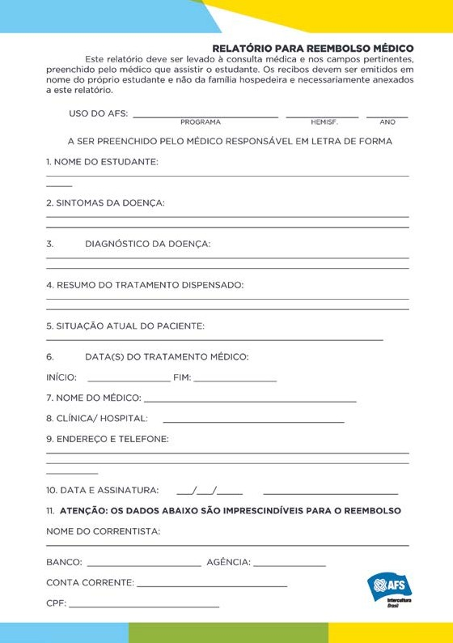
USEFUL FACTS ABOUT BRAZIL
This section offers some tips to help you adjust to the Brazilian culture, especially on how to get along well with your new family. What we are presenting here are generalizations about the Brazilian culture.
Since Brazil is so diverse and also because cultural habits might vary due to many reasons, they might not apply exactly to what you will experience in your local hosting community. However, theses generalizations offer interesting cultural insights about some general aspects of the Brazilian culture. Bear in mind that the best way to learn and integrate to a new culture is to observe and ask questions!

HOST FAMILY
First of all, it is important to remember that that your host family is participating in this exchange because they want to gain as much from the experience as you do. They are opening up their home and hearts to you in the spirit of an intercultural exchange, without any monetary compensation. Your new family members will want to learn as much about you and your background as you should about them.
In many ways your host family will be like all other families. There will be times of joy, times of conflict, and times of simply being together. In one thing your host family is unique: in their generosity. They have opened their home to you so that you can share the life of each family member and their life together. This generosity surpasses any monetary value because no host family is paid to host.

AT HOME
A good way to get into the ‘hang’ of how things are done around the house is to look and learn, but also, to participate! The more you participate in the family activities, the easier it will be for you all to get to know each other better. The first step you will have to take is to become a member of your family. The family is a very close unit in this country. If they are busy, ask if you can help. For politeness, they may refuse your help in the beginning. Under these circumstances, the key action is to insist: “Please, let me help!” (“Por favor, deixe-me ajudar!”) Even if your family has a maid which is fairly common in Brazil be ready to help in the housework.

MAIDS
You may not be used to having a maid at home. In Brazil they are usually treated like a member of the family. Remember that an extra person in the house means extra work for them. So always express your appreciation for the service they deliver to you.

PARENTS
Parental decisions are respected and followed, and the parents have the last word in disciplinary and other family matters. They are concerned about the responsibility of having a new child at home and they expect you to learn their habits and live as another family member. Authority patterns may differ from what you’re used to back home. No problem! You’re here for the challenge of learning and living according to Brazilian patterns. They do not know you yet and as you show how capable you are of taking responsibility it may be easier to accommodate your needs.
Do not question their authority from the start! You will probably hurt them and might strain the relationship. Developing a relationship takes time... and patience. You may not be used to asking permission to go out with friends or to have a curfew, but in most Brazilian families this will be true.
Sometimes house rules may get on your nerves. In the face of opposition, try to stay calm and discuss the problem, in the true spirit of an intercultural exchange. If it seems difficult to do that, you can always go for a long walk; exercise is a good release and it gives you time to think things over you will stay in shape, too!

YOUTH
In general, during the first couple of months you will be part of a small group of your host brother/sister’s friends. Do not expect to be on the go all the time. Do not expect your host sister or brother to become your best friend, but always try to act in a friendly way with him/her. You will notice that, as a rule, children are financially dependent on their parents until they enter University or even until they finish it. Do not expect to do things here as you are used to at home.
Accommodating to that new reality will be part of an intercultural experience. In general, Brazilian boys and girls are raised under some traditional gender distinctions. Despite these gender differentiations, people are used to share the costs of outing and girls are expected to pay their own share.

RELIGION
Brazilian population is used to and believes in a great variety of religions. Brazilian families usually have at least a couple catholic members. Christian religions are the most important and popular. Many families attend weekly religious services and the youth religious movement is getting stronger.

FOOD, EATING AND DRINKING HABITS
Most Brazilians are used to two large meals: lunch and dinner. Breakfast is quick and light. Some families are also used to having a snack in the afternoon. For Brazilians, eating well means eating a lot!
Brazilians enjoy eating and are also very proud of their food. You are expected to gladly taste everything that is offered to you. Home cooking is generally very good, often very rich, too.
Try to always be there at meals time, as in most families it is an important family gathering occasion; if you think you cannot make it, don’t forget to arrange so in advance or call.
Ask before you take food from the refrigerator, it might be planned for something. Notice that offering and sharing any food you are having out of meal time, may be considered as a sign of courtesy.
There are no cultural or religious bans on drinking alcohol as a general rule. Young people are expected to know their limits for drinking and going out just for the sake of getting drunk isn’t popular.
Remember that according to our culture being drunk is no sign of maturity and certainly not accepted by the families. We trust you to treat the availability of alcohol in our country responsibly, too, as the legal drinking age for any kind of liquor 18 is not much enforced. Check out how your family handles it and go along. The same goes for smoking. Remember that AFS Brazil does not accept participants that smoke. If you’ve stated in your application form that you were willing to abstain during the AFS year, keep it in mind as it is certainly what is expected from you. Noncompliance to this rule may lead to your Early Return.

GREETINGS AND NON-VERBAL COMMUNICATION
People generally talk and laugh loudly, and may, sometimes, give the impression of fighting. Body language is widely spread as well as touching the interlocutor arm, shoulder, hands… while talking. Brazilians are very expressive, it is very common to kiss (on the cheeks) when meeting or saying good bye. This habit is also common between parents, children, other family members and friends. Men generally shake hands.

“MAGICAL” WORDS
Say ‘por favor’ (please) and ‘obrigado’ (thank you) at all times those words never go out of style. Saying ‘bom dia’ (good morning), ‘boa noite’ (good night) and ‘tchau’ (good bye) is also a courteous thing to do in Brazil. Brazilians usually say ‘Saúde!’ (Bless you) when others sneeze.

PHONES
Don’t stay on the phone for too long. To call your parents in your home country, we suggest you to use online video calls platforms such as Skype and WhatsApp. This way you will not need to pay any monetary value for your communication with your native parents. Also, an important tip is not to call your parents very frequently as this may strain your experience. Remember you have only a "short" time in Brazil and you will return home at the end of your program.

HYGIENE HABITS
Brazilians enjoy bathing daily. Do not stay in the bathroom too long and be conscious of the needs of the rest of your family. Not taking at least one shower a day is considered something negative in our culture.
It is a habit that in most of the families you wash your own underwear, even if there is a maid. Do so on the first days until you find out how it works in your family.
If there is a waste basket beside the basin, dispose in it toilet paper, pads or tampons. Having a clogged toilet may be an embarrassing experience.

PRIVACY
Our sense of privacy is certainly very different from other cultures. You may wish to stay alone locked in your room reading, writing letters or just listening to music. However, this attitude may lead your host family to understand that you have a problem or that you don’t appreciate their company. So, please, don’t stay locked in your room when the rest of the family is together somewhere else in the house. For instance, if your family gathers to watch TV after dinner, stay with them, even if you do not understand it at all. Try to join your family in every possible occasion.

LANGUAGE
Host families are instructed to help participants whenever needed. Although many host family members can speak English, we suggest you to try to speak Portuguese as much as possible.
It is likely that you will meet people who speak some of your native language and that will try to practice it with you. It is not that they are taking advantage of you. In fact, it is really an exchange. However, if you feel that you are not having enough chance to speak Portuguese, we suggest you to make an agreement with them to set up time for language practice.
Learning the language and trying to follow what is going on is quite a task for the start, but your efforts to understand and your interest will be highly appreciated by all the people involved.

INTERNET, SOCIAL NETWORKING AND ETC.
Just remember, you did not come to Brazil to spend your days at the computer or cellphone, we recommend that you limit your internet use to no more than two hours a day!

POSTAL SYSTEM
In Brazil, the postal system may get packages stuck at Customs, and the recipients needing to pay large amounts to release the parcel. Therefore, we advise students to, along with their native parents, carefully plan what they will bring as baggage and what can be sent afterward. Planning in advance will help students avoid having setbacks.

SAFETY TIPS
During your experience, you will surely find new and different situations along the way and you may not be aware of what is proper and acceptable especially regarding your own safety in our country.
The purpose of this “Safety Tips” is to make recommendations and give you guidelines for your physical welfare and security.

TWO BASIC RULES
1) One way for you to be prepared for any problems, is to carry a photocopy of your passport in your purse or wallet and your Brazilian Id Card at all times. Another important paper to carry is the AFS Medical Card which you will receive after your arrival in Brazil.
You should also carry your host family’s home telephone numbers, and the numbers for your local AFS volunteers and the National Office. In addition, memorize your host family’s numbers.
2) Before agreeing to go out with your friends, you should get permission from your host parents. Always make it a rule to tell them your plans: where you are going, who with, what you are going to do and when you are returning. Your host family knows the most about their community and is best prepared to give you advice about places it would be better for you to avoid and how best to get around. You should take their advice seriously and follow their recommendations.

ALONE AT HOME
When you are alone at home, always make sure the door is locked and chained (if available). Never open the door to strangers, unless your family informs you that someone (relative or friend) is coming.
If someone is at the door, always be sure to check who is there by looking through the peephole (olho mágico) or talking on the intercom before opening the door. If you are unable to understand what that person is saying or you are not sure who it is, ask them to come back later (por favor, volte mais tarde).
Ask your host family what to do when a stranger comes to your home when you are alone: for example, whether or not you should answer the phone or intercom (porteiro eletrônico) or receive deliveries. If yes, ask them how. It is important to know who you should contact in case there is a problem and you are alone at home.

OUTSIDE HOME
Arriving at home unexpectedly
In case you are out of the house and decide to come back at a House keys
If your host family gives you the house key (chave de casa), you should be careful not to lose it. Ask your host family whether you need to lock the doors and windows
when you go out or at night, and when and how to lock them; be sure to follow their instructions correctly.
Ask your host family what you should do in case you lose the house key and you find the house locked. Ask them where you should go and who to phone to.

DANGEROUS AREAS
Ask your host family how safe is your neighborhood, if it is safe to carry your valuables with you (jewelry, money, etc) and if you can be outside the house late at night.
At the earliest opportunity, have your host family and local AFS volunteers teach you where the dangerous areas in your city or region are located and how local people avoid or deal with dangerous situations. It is important for you to know thoroughly the layout and names of places in your area, as well as the times you should particularly avoid such areas.
In many Brazilian state capitals and smaller cities, there are some very poor neighborhoods generally slums which were forgotten by the government for many years and nowadays are ruled by drug dealers.
Although the majority of its residents are workers and friendly citizens, you should not enter these areas and must be alert if you are in the surroundings! In some of these dangerous districts especially in Rio de Janeiro and São Paulo there is a real risk of gunfire and stray bullets.

If You Are Not Used To Crowded Urban Centers...
...there are important advices that you should consider! Try to carry your backpack in the front.
Pay attention at your wallet, purse and other valuable things while walking in crowded streets, buses or subways.
Avoid empty streets since many crimes happen in quiet places. Never carry a lot of money with you.
You should have only what you need for the day. Make sure that you put your money, purse or valuables in your bag, so they are not showing. Be careful about people who may approach you from behind or suddenly talk to you on the street. Also, do not pay attention to any sales talk while walking on the streets.
Beware of street children. While many of them are nice and inoffensive, others are used to steal and have developed smart ways to do it. Don’t underestimate them. They usually act as a group and have the protection of older people.

PUBLIC TRANSPORT
In most Brazilian cities, the main public transportation consist of medium size buses and in general terms they are considered safe to be used during daylight hours. In any public transportation system, you should be careful especially at rush hours, because it is easy for pickpockets to steal.

INTERNET USAGE AND CONCERNS
The information you post online or send electronically can easily become public. When you provide personal contact data “virtually”, you are assuming the risk of being found by someone dangerous in the “real world.”
The same happens when you post or send intimate information and images that may attract bad intentioned people, expose you to cyber bullies and others.
Keep in mind that some material that you naively publish at the web can also damage your reputation.
Be careful about the frequency and the purpose why you access the web. Addiction to Internet has been identified as a major factor to school failure. Besides, it makes you spend much time in the “cyberspace”, missing opportunities for a healthy engagement in a host community where many interesting things are waiting to be discovered. There, in the “real world” is where your host family, friends and schoolmates are living. The exchange program is meant to be a time for creating ties and developing personal relationships, don’t let the Internet take this unique experience from you

THE POLICE
In Brazil, depending on the region and community, the police may not be very reliable. Also, in order to affirm their authority in the dangerous areas, policemen on duty in these places tend to be rude and sometimes do not respect basic rights. Ask your family how reliable is the police in your host community and which precautionary advice you should take in account whenever dealing with them.
It is important that if you find yourself being questioned by the police or other civil authority officer, you show respect and cooperation with them, even though you may be innocent of any crime and think you are being treated unfairly. In such a situation, it is unlikely that you will understand what is being said by the authority figure. In general, the best advice would be to say that you do not understand what is happening and identify yourself as an exchange participant. It is advisable for participants to always carry their Brazilian Identification Card. This is important not only in the event of being questioned by authorities, but also in the unfortunate event of a personal accident or if you become the victim of a crime and may not be able to effectively communicate.

CONCLUSION
The best general advice AFS can recommend regarding issues of personal safety are:
• Get to know the host culture well through questions, dialogue and discussion with your host family, peers, teachers, the AFS local contacts.
• Take seriously any concerns that your host family and host institution have expressed and follow their advice.
• Do not ignore your own “instinct” in any given situation or feel you have to compromise your own personal behavioral values and beliefs. These are valuable resources in making decisions about what to do.

EMERGENCIES
In the event of a personal emergency, please call the following phone numbers in the order:
1. Host family
2. Local AFS volunteer
3. AFS National Office:
(21) 3724-4464 or 0800 0064464 during business hours or (21) 99615 6499 or (21) 99466-3824 after business hours.

Please ask your host family for the following phone numbers and keep them in your personal phone book: neighborhood police station (delegacia do bairro), fire department and a reliable local hospital or family doctor.
In the event of a natural disaster, do whatever is indicated by your host family or AFS local volunteer. AFS Brazil’s national office will contact you at your host family’s house or school in order to be sure that you are safe and will send a report to your sending country’s national office.

KEEP THESE TIPS IN MIND AND ENJOY YOUR STAY IN BRAZIL!

NAMES TO REMEMBER

OUR AFS CHAPTER: _____________________________
CHAPTER PRESIDENT: ___________________________
TELEPHONE: ___________________________________
ADDRESS: _____________________________________
OUR AFS REGION: ______________________________
SCHOOL: ______________________________________
CONTACT TEACHER: ___________________________
TELEPHONE: __________________________________

